Information Technology Systems
ABDURASHIDOV AXRORBEK ABDUSALOM O‘G‘LI

UNIT 1: Information Technology Systems

Lecturer: Farrux Ahmadaliyev

Group: 25-103

Student ID: 250051

Submission date:1.02.2026

BTEC LEARNER ASSESSMENT SUBMISSION AND DECLARATION When submitting evidence for assessment, each learner must sign a declaration confirming that the work is their own.

Learner(Student) ID | 250051
Assessor name: | Farrux Ahmadaliyev
BTEC Programm Title: | Pearson BTEC International Level 3 Information Technology
Unit or Component Number and  Title | UNIT 1 Information Technology Systems
Assignment Title: | Information Technology Systems
Date Assignment Submitted : | 1.02.2026

Outline
Introduction 2
A.P1 – Ways Software Meets Organizational and Stakeholder Needs 3
A.P2 – Explaining How Hardware Meets Organizational and Stakeholder Needs 8
A.P3 – Ways Data Transmission Methods and Networks Meet Organizational and Stakeholder Needs 13
A.M1 – Analysis of the Impact of IT Infrastructure on the Organization and Its Stakeholders 18
A.D1 – Evaluation of the Impact of IT Infrastructure on the Organization and Its Stakeholders 20
B.P4 – Explaining How Data Is Used Within the Organization 22
C.P5 – Explaining How Internal and External Information Is Used and Shared in the Organization 23
B.M2 – Analysis of the Use of Internal and External Information and Data in the Organization 25
D.D2 – Evaluating the Impact of Using Data and Information on the Organization, Its Stakeholders, and Relevant Policies 26
D.P6 – Describing Internal and External Threats to Information and Data in the Organization 27
D.P7 – Describing Actions That Help Protect Information and Data in the Organization 28
D.P7 – Describing Procedures Required to Enable Legal, Moral, and Ethical Use in the Organization 29
D.M2 – Analyse how threats, and mitigation of those threats, impact the organisation and its stakeholders. 30
D.M3 – Analyse how suggested procedures that ensure the organisation works in a legal and ethical way would impact the organisation and its stakeholders. 31
D.D3– Justifying the Decisions and Approaches Used When Developing Policies 31
Conclusion 33
References 34

Introduction
The modern retail market is no longer defined only by product variety or pricing strategy. In today’s competitive environment, the stable operation and growth of organizations strongly depend on how effectively and strategically they use information technology (IT). IT systems are no longer just supportive tools that automate sales processes; they now act as the core of the business. Sales operations, inventory control, customer relationships, financial monitoring, and management decisions all rely on the quality and reliability of the IT infrastructure.
Tech House is a retail company that sells household appliances and currently operates five physical stores across the country. The company is now entering a new stage of development by planning to expand its business and introduce an e-commerce platform. This growth naturally increases operational complexity. As sales volumes rise, product ranges expand, and the number of branches grows, managing sales, warehouse, employee, and customer data separately and partly manually becomes inefficient. This situation leads to problems such as lack of real-time accurate information, data duplication, errors, and delays in management decision-making.
The main purpose of this report is to analyze the current situation of TechHouse from the perspective of a professional IT consultant and to justify optimal IT infrastructure solutions that can support both its physical stores and future e-commerce activities. The report explains in detail how software, hardware, and network infrastructure can meet the needs of the organization and its key stakeholders, including management, employees, customers, and suppliers. In addition, the impact of IT infrastructure on operational efficiency, management quality, and the company’s long-term competitiveness is evaluated within a real business context.

A.P1 – Ways Software Meets Organizational and Stakeholder Needs
TechHouse operates several physical stores, a central warehouse, and plans to launch an ecommerce platform in the near future. In such a business environment, the choice of software has a direct impact on the company’s efficiency and long-term stability. When separate systems are used for sales, inventory, customer management, and finance, gaps appear between processes. This makes it difficult to access complete and reliable real-time information.
For this reason, TechHouse requires a single, integrated software platform. Based on these needs, the company has selected Odoo ERP as its main system. Odoo ERP is a modular software solution that combines key retail functions such as sales, point of sale (POS), inventory management, customer relationship management (CRM), finance, and e-commerce within one unified platform.
This system helps TechHouse centralize previously fragmented processes and manage all essential data through one shared database. As a result, smooth and continuous information flow is ensured between all stores, the warehouse, and online sales channels, supporting better coordination and decision-making across the business.
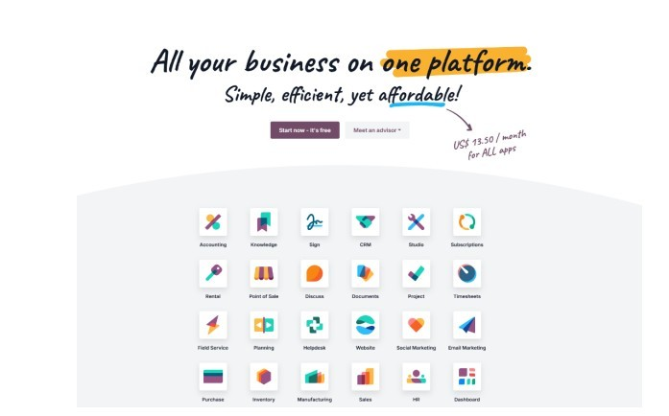

Picture 1(Odoo ERP dashboard – sales and inventory overview

From an organizational needs perspective, Odoo ERP improves operational efficiency by automating sales and inventory processes. Every sales transaction completed through POS systems in physical stores is automatically synchronized with the inventory system. This ensures that stock levels are updated in real time and helps reduce issues such as incorrect calculations, overstocking, or product shortages. Managing sales and warehouse operations within one unified system allows Tech House to use its resources more effectively and make better operational decisions.
Odoo ERP also fully supports e-commerce activities. Through the e-commerce module, online orders are directly connected to sales and inventory systems. When a customer places an order, product availability is checked automatically, and the order is processed based on actual stock levels. This prevents gaps between physical stores and online sales, reducing incorrect orders, delays, and customer dissatisfaction. As a result, Tech House is able to create a single omnichannel sales environment that connects all sales channels smoothly.
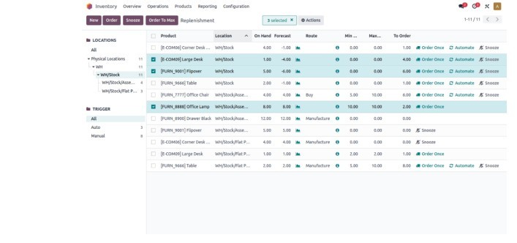
Picture2. Odoo e-commerce module – online product catalogue and ordering system

The modular structure of the system matches the company’s future growth needs. When new stores are opened or sales volumes increase, there is no need to fully replace the existing platform. Instead, the system can be adapted by adding more users or implementing additional modules. This approach helps keep IT costs under control and ensures the long-term stability of the infrastructure.
For management and company owners, Odoo ERP is an important tool that supports decisionmaking. Through management dashboards, key data such as sales performance, revenue, expenses, and inventory status can be monitored in real time. Based on this information, management can identify which products are in high demand, which stores are underperforming, or where costs are increasing. This makes it easier to make fast and strategic business decisions.
For employees, Odoo ERP simplifies daily work processes and improves accuracy. Cashiers can record sales transactions quickly, warehouse staff can monitor stock movement in real time, and managers can track operations through reports. However, the implementation of the system requires staff training and an adaptation period. If this process is not planned properly, work efficiency may temporarily decrease at the early stage, highlighting the importance of the human factor in system adoption.
From the customer’s perspective, Odoo’s e-commerce and CRM modules improve service quality. Customers can view products online, check availability, place orders, and track order status. Through the CRM module, customer purchase history and preferences are stored, allowing personalized offers and more effective customer service. This increases customer trust and long-term loyalty.
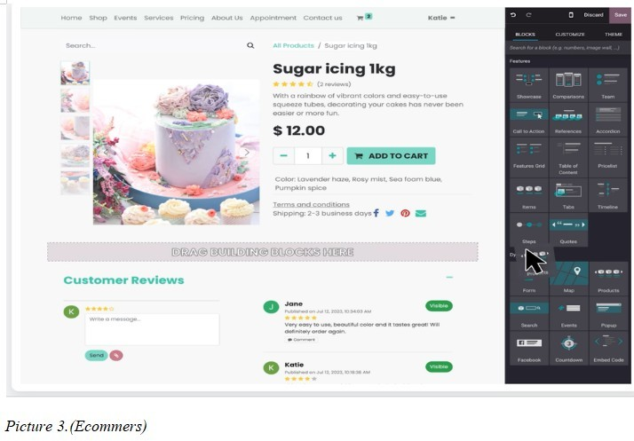
Inventory and supply processes are also managed efficiently through Odoo software. Using Odoo’s Inventory Management module, Tech House can track stock levels in the warehouse, receive automatic alerts for low-stock items, and improve coordination with suppliers. This helps prevent issues such as product shortages or excess inventory, which are critical for the company. As a result, the organization is able to use its financial resources more wisely.
For the marketing and customer service departments, Odoo’s CRM module plays an important role. This module allows the company to analyze customer purchase history, contact information, and behavior. Based on this data, Tech House can send personalized offers, organize promotions, and improve service quality. As a result, marketing strategies become more effective and long-term relationships with customers are developed.
When working with suppliers and external partners, Odoo ERP makes the supply chain more transparent. When inventory levels fall below a defined threshold, the system makes it easier to plan replenishment orders, reducing delays and improving coordination. However, since not all suppliers may be equally digitalized, additional adjustments and coordination may be required in some cases.
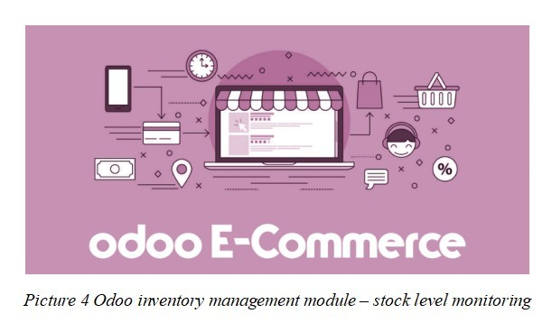
The owner of Tech House and the management team also gain significant benefits from using Odoo software. Odoo’s reporting and analytics modules provide management with real-time information on sales performance, revenue, expenses, and inventory status. Based on this data, the company can make fast and well-informed decisions, such as identifying which products should be purchased in larger quantities, which stores are underperforming, or how to develop strategies to expand the ecommerce platform.
In addition, Odoo software is able to support TechHouse’s future development needs. The modular design of the platform allows the company to add new features as the business grows. For example, when a new store is opened or online sales volume increases, there is no need to replace the entire system. Instead, the existing platform can be expanded, saving both time and costs.
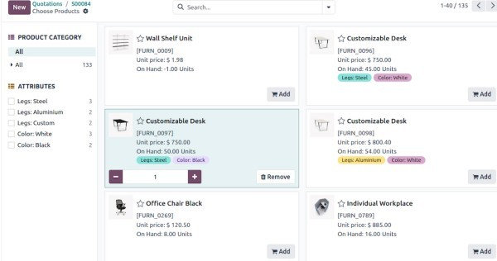
Picture 5. Odoo CRM
At Tech House, Odoo CRM is used to centralize customer management processes and improve service quality. This system allows all customer-related data to be stored on a single platform and used accurately in daily operations as well as in strategic decision-making. Odoo CRM works in an integrated way with both physical stores and the planned e-commerce platform at TechHouse, ensuring that customer information is updated in real time.
At Tech House, customer data is automatically collected into the Odoo CRM system from multiple sources. Sales transactions completed in physical stores are recorded through the POS system, and each purchase is linked to the relevant customer profile. Customer contact details, order information, and payment status from online purchases are also stored in the CRM system. As a result, a single digital profile is created for each customer, clearly showing their purchase history, products of interest, and previous interactions.

A.P2 – Explaining How Hardware Meets Organizational and Stakeholder Needs

At Tech House, the effective operation of information systems depends not only on software but also on suitable and reliable hardware. Managing several physical stores, a warehouse, and the head office through a centralized system requires a hardware infrastructure that is stable, scalable, and suitable for daily operations. Properly selected devices help improve operational efficiency and support the needs of key stakeholders within the organization.
At the store level, POS terminals are one of the main hardware components used by TechHouse. These devices operate in integration with the Odoo POS module and allow sales transactions to be processed quickly and efficiently. Each sale is recorded through the POS system and automatically synchronized with the inventory system. This simplifies daily tasks for cashiers and sales staff, reduces customer waiting times, and ensures faster and more accurate customer service.
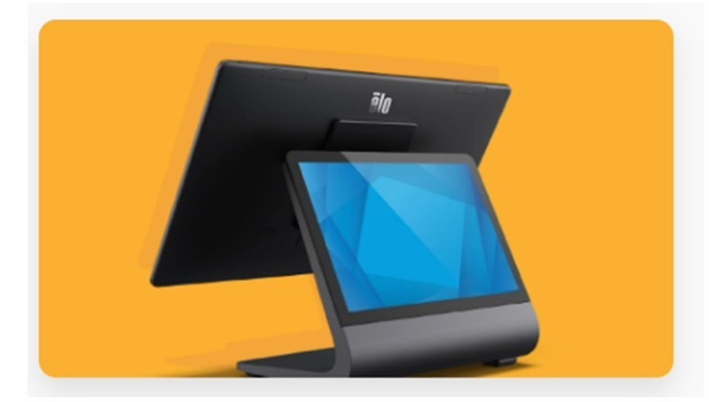
Picture 6.POS
Devices that support POS systems, including barcode scanners and thermal receipt printers, help ensure accuracy and continuity in the sales process. Barcode scanners allow products to be identified quickly and correctly, reducing errors caused by manual data entry. Thermal printers make it possible to print receipts immediately after each sale. These devices not only make the work easier for employees but also create a more convenient and professional shopping experience for customers.
In warehouse operations, hardware plays an important role in effective inventory management. Workstation computers and mobile barcode scanners used by warehouse staff allow stock movements to be recorded in real time. Through these devices, data is automatically transferred to the Odoo inventory module, helping the company identify product shortages or excess stock in a timely manner. As a result, cooperation with suppliers is planned more accurately, and delays in logistics processes are reduced.

Picture 7. Barcode scanner and receipt printer supporting POS operations
At the head office and management level, laptops, desktop computers, and mobile devices are important hardware tools for managers. Through these devices, managers can access the system remotely and monitor sales performance, inventory status, and financial reports in real time. This helps speed up the decision-making process and improves overall management efficiency.
For senior management, laptops, tablets, and mobile devices provide flexible remote access to the system. This allows key stakeholders to quickly track sales results, financial performance, and inventory data at any time, supporting timely and informed decisions.
At Tech House, the use of POS terminal systems enables full digitalization and centralization of sales processes, creating a single integrated sales environment across all physical stores and the future e-commerce platform. Each sales transaction is recorded in real time through the POS terminal, products are identified using barcodes, prices are calculated automatically, and payments are processed securely. This reduces errors caused by human factors and increases service speed.
The POS system is integrated with inventory management, meaning that sold products are automatically deducted from stock, remaining quantities are updated, and low-stock alerts are generated automatically. This supports effective planning of warehouse and supply processes. In addition, the POS database generates centralized reports on sales statistics, revenue performance, product movement, and employee activity. These reports provide management with valuable analytical information that supports strategic decision-making.
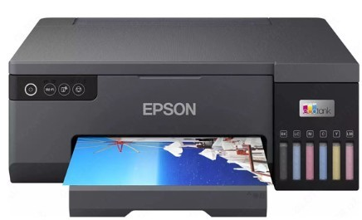Picture 8.Epson printer
Server infrastructure is still a key part of TechHouse’s hardware architecture, but in this scenario it is best provided through a cloud-hosted environment. Because TechHouse plans to run Odoo through managed cloud hosting (for example, Odoo Online/Odoo.sh or a managed hosting provider), the company does not need to maintain large on-premise application servers in each location. Instead, the priority becomes reliable internet connectivity, secure network equipment, and stable endpoint devices. TechHouse should also set up regular backup and recovery procedures (such as scheduled database exports and tested restores) so business data can be recovered if there is a service outage or accidental data loss.
Network devices, including routers, switches, and Wi-Fi access points, also play an important role in Tech House hardware infrastructure. These devices provide stable and fast communication between stores, the warehouse, and the head office. Having a secure internal network for employees and a separate Wi-Fi network for customers helps maintain a balance between security and user convenience.
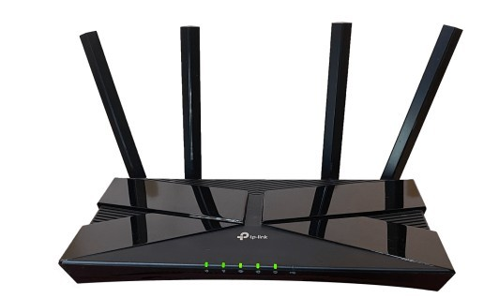
Picture 9.Router

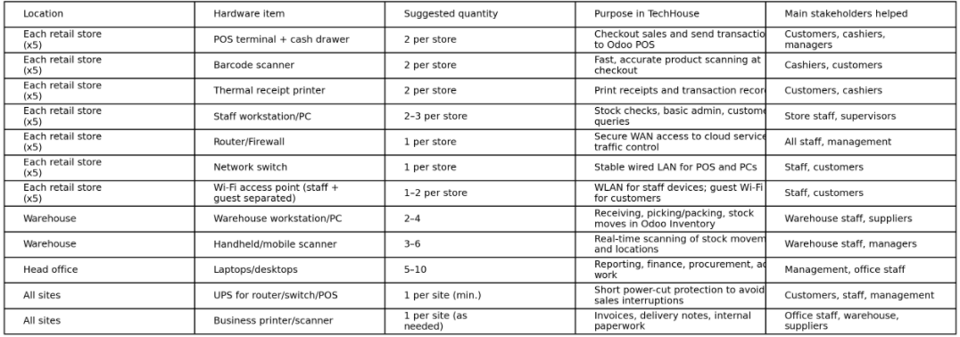
Table 1. IT Hardware for TechHouse (5 Retail Stores + Warehouse + Head Office)

A.P3 – Ways Data Transmission Methods and Networks Meet Organizational and Stakeholder Needs

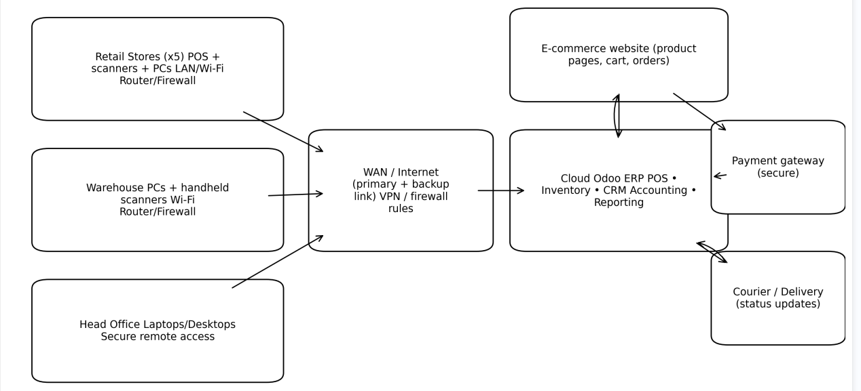
Diagram 1.High level IT System architecture(Tech house)

Data transmission methods and networks are a key part of modern IT infrastructure, as they enable information exchange both within and outside an organization. For a retail company like Tech House, which operates several physical stores and plans to introduce e-commerce, a reliable and secure network infrastructure is essential for uninterrupted business operations. Effective use of the Odoo ERP system also depends directly on stable network and data transmission technologies.
Within the stores and the head office, most data traffic is handled through a Local Area Network (LAN). POS terminals used at checkout points, warehouse computers, and employees’ workstations are connected to the network through wired connections. The main reason for this is stability and speed. Since sales processes are sensitive to delays, data transmitted through the LAN reaches the Odoo system in real time.
If this network environment is unstable, sales transactions may slow down, inventory data may be updated late, and management may not be able to see the real operational situation. For this reason, the LAN serves as the core network that supports sales activities and internal operations at Tech House.
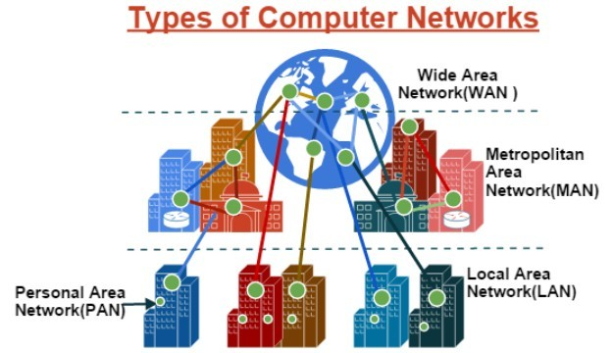
Picture 11.Network system
The WLAN (Wi-Fi) network at TechHouse plays a supportive but important role. Wi-Fi is mainly used to connect mobile devices, tablets, and other portable tools that employees use during daily tasks. For example, during product receiving or placement in the warehouse, using the Odoo Inventory module over Wi-Fi helps speed up work and increases flexibility. However, Wi-Fi should not be the main foundation for checkout devices because signal quality can drop due to interference or overload, which could slow down sales activities.
The Wide Area Network (WAN) is different: it is the business internet/corporate connection that links each TechHouse store, the head office, and the warehouse to the cloud-hosted Odoo system and other online services. If the WAN connection fails, multiple locations may lose access to cloud services at the same time. For continuity, TechHouse should plan for WAN resilience (for example, a secondary ISP line or 4G/5G failover) and prioritize business traffic over guest Wi-Fi.
The Wi-Fi network provided for customers serves a completely different purpose. This network allows only internet access and has no connection to sales systems or devices working with Odoo. Since customer devices are not controlled by the company, allowing them access to internal systems would create serious security risks. For this reason, customer Wi-Fi at TechHouse operates separately and does not affect internal business processes.
In some cases, a Personal Area Network (PAN) may also be used. For example, employees’ personal devices, wireless scanners, or other short-range devices can connect through PAN. These types of connections do not directly control sales systems but help support warehouse or service activities. At Tech House, PAN is used for limited, short-range tasks, which helps reduce unnecessary load on the main networks.
Considering that Odoo ERP is a cloud-based system, the overall purpose of all these networks is to ensure secure and uninterrupted access to Odoo servers through a reliable internet connection. Every sales transaction, inventory update, or online order is transmitted through the network. If the network is poorly designed, for example if Wi-Fi becomes overloaded or internal connections are not properly secured, system performance will decrease and the entire business operation may be affected.
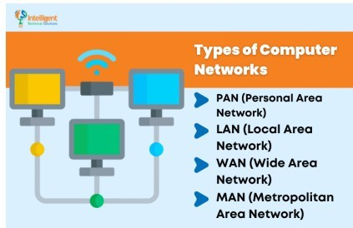Picture 12.Networks
For this reason, cybersecurity is an essential part of Tech House network infrastructure. Since sales and customer data are transmitted through the network, the communication environment must be protected from unauthorized access and malicious traffic. Devices used by employees, sales systems, and remote access connections are kept under strict control. Otherwise, even a single security breach could lead to POS data theft, leakage of customer information, and serious damage to the company’s reputation.
Communication between TechHouse’s stores, head office, and warehouse is provided through broadband internet and corporate networks. Through this network infrastructure, all branches are connected to a single centralized database within the Odoo system. As a result, sales, inventory, and customer data are updated in real time. This allows employees to work with consistent and reliable information and helps reduce operational errors.
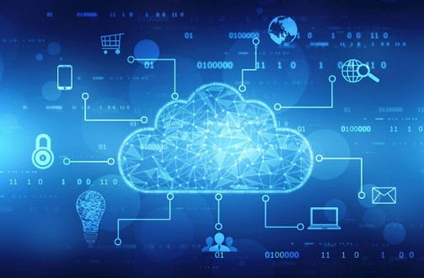
Picture 13. Cloud
To support a centralized system, cloud-based data transmission plays a critical role. The cloud-based operation of Odoo allows Tech House to access the system via the internet without the need for direct physical server connections. This approach provides flexibility, as the network infrastructure can be expanded quickly when new stores are opened or online sales volumes increase. It also enables managers and senior staff to access the system remotely.
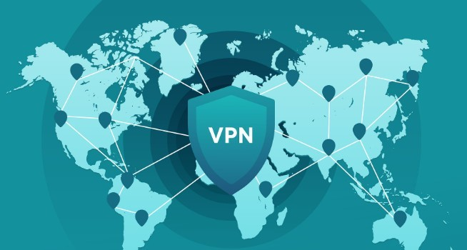
Picture 14. VPN
To meet both internal and external communication needs, secure network solutions such as VPNs and protected connections are very important. These technologies allow employees and management staff to securely access company data from external locations. This creates convenience for key stakeholders, especially managers and IT staff, while ensuring data confidentiality and protection.
Although Odoo ERP being hosted in the cloud gives TechHouse flexibility and scalability, it also increases the importance of a reliable communication environment. Due to dependence on internet connectivity, network interruptions or poor connection quality can affect all stores at the same time. Therefore, stability, reliability, and continuity are key criteria when selecting and planning communication systems. This approach reduces the risk of sales disruptions and supports stable business operations.
From a security perspective, the communication environment is also highly important for Tech House. Since sales and customer data are transmitted over the network, unauthorized access to this information could lead to serious financial losses and reputational damage. For this reason, measures such as allowing access only to necessary systems, controlling remote access, and protecting data transmission help reduce business risks.
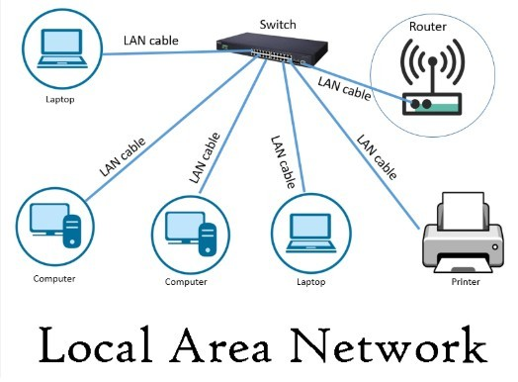
Picture 15.LAN
In-store Local Area Networks (LAN) and Wi-Fi networks enable fast data exchange between POS terminals, work computers, and mobile devices. This supports uninterrupted sales operations and increases the speed of customer service. At the same time, having a secure network for employees and a separate Wi-Fi network for customers helps ensure both security and convenience.

A.M1 – Analysis of the Impact of IT Infrastructure on the Organization and Its Stakeholders

IT infrastructure has a significant impact on an organization not only from a technical perspective, but also at operational, management, and strategic levels. For a retail company like TechHouse, which operates several physical stores and aims to expand e-commerce activities, an integrated IT infrastructure directly determines how business processes function. An infrastructure built around the Odoo ERP system can have both positive and potential negative impacts on the company and its stakeholders.
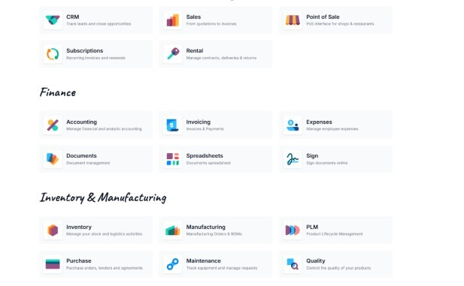
Picture 16 Odoo Menu
A centralized IT infrastructure has a positive effect on TechHouse’s internal operations. Through Odoo ERP, sales, inventory, customer, and financial data are combined into a single system, which speeds up information sharing between departments. As a result, employees work with the same data, reducing the risk of using incorrect or outdated information. This improves work efficiency. However, employees may require training and time to adapt to the new system, which can temporarily reduce productivity during the initial implementation stage.
The impact of IT infrastructure is even more noticeable at the management level. Real-time reports and analytical data allow management to make faster and more informed decisions. The company owner can monitor sales performance, revenue, and inventory status through one platform. This supports strategic planning. However, the stable operation of the infrastructure creates strong dependence on internet connectivity and servers. If a network failure or system downtime occurs, decision-making processes may also slow down temporarily.
At the organizational level, the main positive impact of IT infrastructure is seen in increased operational efficiency. Managing sales, inventory, and financial data within a single system reduces duplicate work and minimizes errors caused by human factors. Faster data sharing between stores allows Tech House to identify, in real time, which products are selling well and which branches are facing problems. This enables management to make quick and well-based decisions. However, this level of centralization also creates a new dependency: if the IT infrastructure fails, multiple business processes may be affected at the same time.
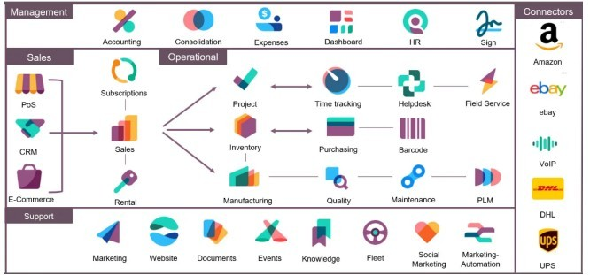
Picture 17 Odoo CRM
For customers, the impact of IT infrastructure is mainly reflected in service quality. Integrated ecommerce and POS systems provide customers with accurate and reliable information about product availability, order status, and delivery processes. This improves the customer experience and increases trust in the company. At the same time, security weaknesses or system failures within the IT infrastructure can threaten the safety of customer data, which may negatively affect customer trust.
IT infrastructure is also important for suppliers and external partners. Through the Odoo system, order and inventory information is clearly visible, which improves supply chain coordination and reduces delays. However, not all partners may be equally prepared for digital systems, which can require additional coordination during the adaptation process.
From a security and data protection perspective, IT infrastructure has a dual impact on the organization. Strong servers, network devices, and backup systems help protect data and ensure continuous operation. At the same time, a centralized infrastructure increases cybersecurity requirements, as a single system failure or cyberattack can affect multiple processes simultaneously.

A.D1 – Evaluation of the Impact of IT Infrastructure on the Organization and Its Stakeholders
IT infrastructure has a direct impact on the efficiency and stability of an organization. In the case of Tech House, an integrated IT infrastructure built around the Odoo ERP system creates significant benefits for the organization and its stakeholders, while also introducing certain risks and limitations. Therefore, it is important to evaluate its overall impact by considering both positive and negative aspects together.
The evaluation shows that a centralized IT infrastructure significantly improves operational efficiency at Tech House. Managing sales, inventory, customer, and financial data within a single system through Odoo speeds up employee tasks and reduces errors caused by human factors. While this provides clear benefits for employees and managers, the initial implementation costs and the need for staff training may create temporary financial and organizational pressure for the company.
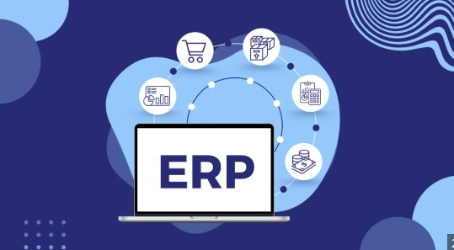
Picture 18. ERP
From a management perspective, the value of the IT infrastructure is mainly reflected in improved decision-making quality. Real-time data and reports help increase the company’s competitiveness and support strategic development. However, this advantage is strongly dependent on the stable operation of the IT infrastructure. If technical issues or internet outages occur, management processes may slow down and reduce the effectiveness of decision-making.
For customers, the impact of IT infrastructure is mainly evaluated through service quality and reliability. Integrated e-commerce and POS systems provide accurate information, fast service, and a convenient shopping experience, which increases customer loyalty. At the same time, security weaknesses or data-related issues within the IT infrastructure can seriously damage customer trust. Therefore, if sufficient attention is not given to security measures, the positive impact of the infrastructure may be reduced.
For suppliers and external stakeholders, IT infrastructure simplifies the supply chain and increases transparency. This improves cooperation and reduces delays. However, not all suppliers may be equally digitalized, which can limit the full effectiveness of the infrastructure and require additional adaptation efforts.

B.P4 – Explaining How Data Is Used Within the Organization

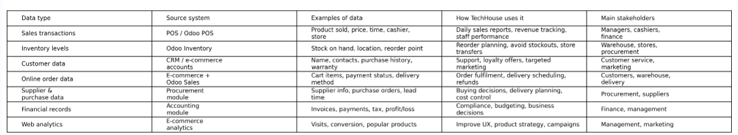
Data is one of the most important resources in modern organizations because it is used to manage daily operations and control business processes. In a retail company like TechHouse, data is regularly collected from sales, warehouse activities, customers, and online orders. This data is used to meet internal organizational needs and to improve service quality.
Sales data at Tech House is collected through POS systems in physical stores and through the online sales platform. Each time a purchase is made, information such as product name, quantity, price, and date is recorded. This data is used to monitor daily sales activities, calculate revenue, and control cash register operations. Sales staff and managers can also use this information to evaluate work performance.
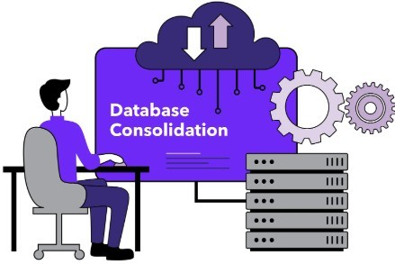
Picture 19 Data Consolidation
Inventory data includes information about product quantities in stores and warehouses, stock movements, and delivery processes. This data is continuously updated through the inventory management system and is used to prevent product shortages or excess stock. Warehouse and logistics staff use this data to order and store products on time and in the correct quantities.
Customer data includes contact details, purchase history, and customer preferences. This information is stored in the CRM system and is used to improve customer service. For example, customer service staff can provide faster and more accurate support based on previous purchases. This data is important for understanding customer needs and offering suitable services.
Data related to online orders is collected through the e-commerce platform. Information such as order status, payment method, and delivery address is used to ensure that orders are processed correctly and on time. Using this data, Tech House can keep customers informed about their orders and improve overall service quality.
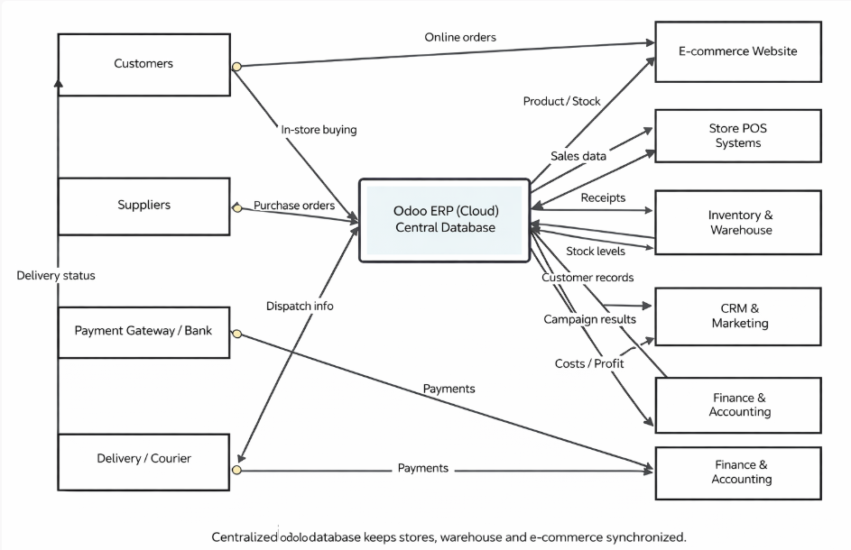

C.P5 – Explaining How Internal and External Information Is Used and Shared in the Organization

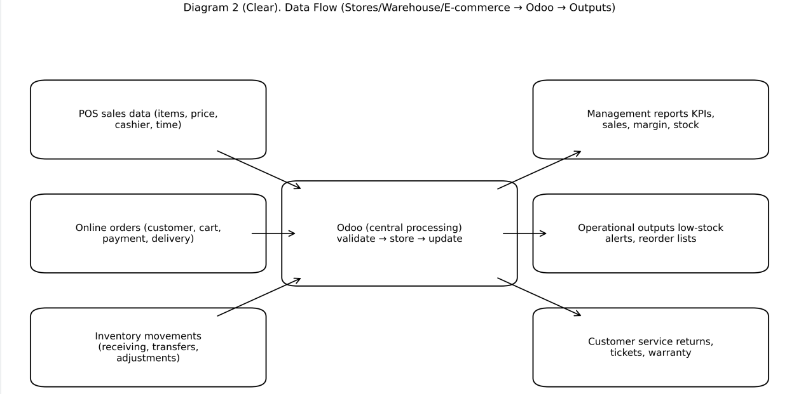

At Tech House, internal and external information is collected, processed, and shared through clearly defined IT systems. These processes are centralized using ERP, POS, and e-commerce systems to ensure accuracy, efficiency, and proper control of information flow. Clear Use of Internal Information
At TechHouse, internal information is mainly used to support sales, inventory management, and management activities. Every time a sale is completed, product name, price, quantity, and date are automatically transferred from the POS terminal to the ERP system. This sales data is updated in real time and can be viewed by managers through dashboards.
Inventory information is updated automatically based on stock levels in stores and the warehouse. When a product is sold or new stock is received, the system recalculates inventory levels and sends automatic alerts for low-stock items. Warehouse staff use this information to place orders with suppliers in a timely manner.
At the management level, senior staff review sales performance, inventory status, and financial results through ERP reports. Based on this internal information, decisions are made about which products sell the most, when sales decrease, and how resources should be allocated.
Internal information is only available to authorized employees. For example, cashiers can access sales data only, while managers have additional access to inventory data and management reports. Clear Use and Sharing of External Information
External information is mainly used in processes related to customers and suppliers. Through the TechHouse e-commerce platform, customers can see accurate and regularly updated product names, descriptions, prices, and availability. When a customer places an order, the order details are automatically sent to the ERP system.
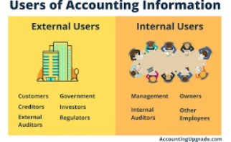
(Picture 20 Users of Accounting Information)
After an order is received, the customer is sent an electronic order confirmation message. During the delivery process, the order status is updated, and the customer can track this information online. This external information improves transparency and service quality for customers.
Information exchange with suppliers is based on inventory data. When stock levels fall below a defined limit, a purchase order is sent to the supplier through the system. Order details are shared electronically, which speeds up the supply process and reduces errors.
For marketing purposes, external customer data is used through the CRM system. Based on previous purchases, customers may receive messages about discounts, promotions, or new products. This information is used only for specific purposes and is shared based on customer consent. Security and Control
Security is strictly controlled when sharing both internal and external information. Internal data remains within the organization and is not shared with unauthorized individuals. External data is limited to what is necessary for each process. This approach ensures that information at Tech House is used accurately, securely, and responsibly.

B.M2 – Analysis of the Use of Internal and External Information and Data in the Organization

In a retail organization like Tech House, internal and external data and information are used in different ways at different levels of the business. These information flows help improve operational efficiency, support decision-making, and strengthen communication between stakeholders. The way internal and external information is used and managed has a direct impact on the overall performance of the organization.
Internal data, including sales results, inventory status, and financial indicators, is mainly used to manage internal processes. This information is updated in real time through the ERP system and shared across departments. As a result, managers can compare the performance of different stores, and employees can work using accurate and up-to-date information. This improves internal coordination. However, heavy reliance on data and systems may increase employees’ dependence on technology.
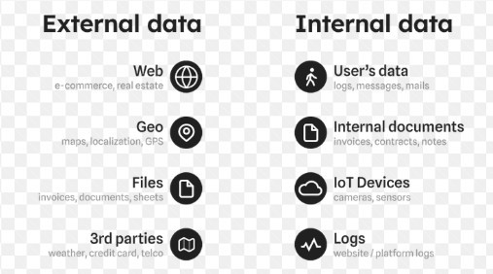
Picture 21. Internal and External Information
At the management level, internal information has strong strategic importance. Through reports and analytical data, the company owner and senior management can evaluate sales trends, seasonal changes, and cost structures. This allows decisions to be made faster and more accurately. At the same time, if internal data is incorrect or incomplete, there is a risk of poor strategic decisions, which could negatively affect the entire organization.
The use of external information is mainly seen in processes related to customers and suppliers. Product information, order status, and delivery details provided to customers play an important role in shaping the company’s image. Accurate and reliable external information increases customer trust, while incorrect or delayed information can lead to customer dissatisfaction.
External information shared with suppliers directly affects inventory management and the supply chain. Clear and accurate information about orders and demand helps stabilize supply processes and reduce delays. However, because external partners may have different levels of technological capability, information exchange may sometimes require additional coordination.
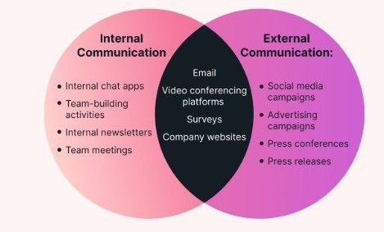
Picture 22. Internal and External Communication
The use of internal and external information is closely connected, as each influences the other. For example, internal sales data forms the basis for external marketing information, while external customer feedback influences internal decision-making processes. From this perspective, effective management of information flows increases organizational efficiency, while poor management can create operational and strategic risks.

D.D2 – Evaluating the Impact of Using Data and Information on the Organization, Its Stakeholders, and Relevant Policies
The use of data and information has a direct impact on both the operational and strategic activities of a retail organization like Tech House. Effective use of sales, inventory, and customer data helps optimize business processes, but if these processes are not managed properly, they can also create significant risks for the organization. For this reason, the impact of data usage must be evaluated by considering both positive and negative aspects.
At the organizational level, the use of data improves the quality of decision-making. Based on accurate and real-time information, managers can identify sales trends, allocate resources efficiently, and control costs. However, if data is collected incorrectly or interpreted wrongly, there is a risk of making poor strategic decisions. This highlights the need for control mechanisms in data usage processes.
For stakeholders, especially customers, the use of data strongly affects trust. Using customer data to improve service quality and create personalized offers has positive results. However, if this data is not properly protected or is used outside its intended purpose, customer trust may decrease and the company’s reputation can be damaged. Therefore, data usage has a direct impact on long-term customer relationships.
For employees, access to accurate and up-to-date data increases work efficiency. However, if access rights are not clearly defined, there is a risk of internal errors, incorrect data sharing, or disclosure of confidential information. This increases the importance of internal policies that regulate employee access and data usage.
Policies related to data and information usage act as an important protection mechanism for the organization. Clear policies on confidentiality, data protection, and acceptable use strengthen the positive impact of data usage and reduce risks. On the other hand, poorly designed or weakly enforced policies may lead to legal, ethical, and operational problems. At the same time, overly strict policies may slow down information access and negatively affect work processes.
Overall, the impact of data and information usage on the organization, stakeholders, and policies is closely interconnected. If data usage processes are not managed in a balanced way, the balance between benefits and risks for the organization may change.

D.P6 – Describing Internal and External Threats to Information and Data in the Organization
Because information and data are a critical part of organizational operations, they are exposed to various internal and external threats. In a retail organization like TechHouse, the presence of sales data, customer information, and financial records increases the need for strong data protection. These threats can arise from internal factors within the organization or from risks in the external environment.
Internal Threats
Internal threats are related to employees, processes, or technical systems and are often caused by human factors. For example, employees using weak or repeated passwords increase the risk of unauthorized access to information systems. If such passwords are discovered by others, sensitive data may be exposed.
Lack of employee training and awareness is also an internal threat. Incorrect entry of customer data, accidental deletion, or sending information to the wrong recipient can damage data accuracy and reliability. These issues often occur when clear internal rules and data-handling guidelines are not in place.
Internal threats may also appear in technical form. For example, failure to create regular backups or incorrect backup configuration can lead to data loss. In cases of system failure or technical errors, this can seriously affect organizational operations.
External Threats
External threats come from individuals or factors outside the organization and mainly involve cybersecurity risks. Examples include hacking attacks that aim to gain unauthorized access to systems, steal data, or modify information. Such attacks can damage customer personal data and financial records.
Social engineering attacks, such as phishing, are also external threats. In these cases, employees are tricked through fake emails or websites into revealing confidential information. This can lead to unauthorized access to internal systems.
In addition, external threats may be related to technical infrastructure. Internet outages, attacks on servers, or failures of external service providers can temporarily prevent access to data. This can cause delays in sales operations and customer service.
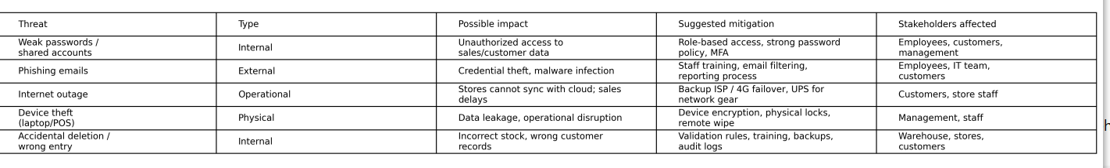

D.P7 – Describing Actions That Help Protect Information and Data in the Organization
Protecting information and data is essential for maintaining business continuity and stakeholder trust. In a retail organization like Tech House, where customer, sales, and financial data are processed, clear and structured protection measures must be implemented.
One of the main actions is access control. Only authorized employees are allowed to access systems, and each employee is given access based on their job role. This reduces internal threats and prevents unauthorized access to data.
Using strong passwords and authentication rules is another important protection measure.
Employees are required to use complex passwords, change them regularly, and not share them with others. This reduces the risk of unauthorized access from both internal and external threats.
Data backup is also critical for information protection. Important data is backed up regularly and stored securely. This allows data to be recovered in case of system failure, accidental deletion, or technical issues.
Data encryption is used to protect stored and transmitted information. When data is encrypted, it is difficult to read even if it is accessed by unauthorized parties. This is especially important for customer and financial data.
Network security is supported through firewalls and protected networks. These measures limit malicious traffic and help prevent external attacks. In addition, having separate networks for employees and customers increases overall security.
Employee training and awareness are also essential. Staff are educated about information security rules, phishing risks, and correct data-handling practices. This helps reduce risks caused by human error.

D.P7 – Describing Procedures Required to Enable Legal, Moral, and Ethical Use in the Organization
The use of IT systems in an organization must follow not only technical standards but also legal, moral, and ethical requirements. In a retail organization like TechHouse, where data related to customers, employees, and partners is processed, clear procedures must be in place to ensure responsible and lawful use of IT systems.
To ensure legal compliance, procedures for data protection and confidentiality are established. Employees are allowed to use personal customer data only for work-related purposes and defined objectives. Unauthorized copying, sharing, or disclosure of data to third parties is strictly prohibited. These procedures help ensure compliance with data protection laws.
To support moral and ethical behavior, Acceptable Use policies are implemented. These policies define that company computers, internet access, and email systems should be used only for workrelated activities. Any illegal, harmful, or inappropriate use of organizational resources is not allowed.
Fair and equal access procedures are also important. Employees must not be discriminated against in system access, data must not be used for personal benefit, and the same rules must apply to all users. This supports ethical standards within the organization.
Consent and awareness procedures also support legal and ethical use. Customers are informed about how their data is collected, stored, and used. Employees confirm that they understand and accept IT policies and procedures. This increases transparency and builds trust.
Finally, monitoring and accountability procedures are applied. Employee use of IT systems is monitored, and disciplinary actions are taken if policy violations occur. These procedures encourage responsible behavior and ensure compliance with ethical standards.

D.M2 – Analyse how threats, and mitigation of those threats, impact the organisation and its stakeholders.
Threats to information and data have varying degrees of impact on the organization’s operations. In a retail organization like Tech House, internal and external threats directly impact sales processes, customer trust, and management effectiveness. Mitigating these threats can have both positive and negative consequences for the organization and its stakeholders.
Internal threats, such as employee noncompliance or data mishandling, can have a negative impact on the organization’s internal processes. To mitigate these threats, limiting access rights and implementing strict policies can reduce the likelihood of employees gaining unauthorized access to data. This increases data security, but these restrictions can slow down workflows for some employees and create additional approval steps.
External threats, including cyberattacks and phishing, have a strong impact on an organization’s reputation and customer trust. Using firewalls, encryption, and monitoring systems to mitigate these threats increases the level of data protection. This gives customers confidence that their personal data is being stored securely, but such technical measures create additional costs and maintenance requirements for the organization.
From a management perspective, threat mitigation measures affect management stability. When security policies and control mechanisms are in place, decisions are based on reliable information and business continuity is ensured. At the same time, when security requirements are increased, management has to make balanced decisions, taking into account technical risks and costs.
The impact of threat mitigation measures on customers is mainly manifested in the quality of service and reliability. Secure systems protect customer data and increase their trust in the company. However, if security processes are overly complex, such as multi-factor authentication or slow systems, it can be frustrating for customers.
Mitigating threats to employees is done through training and supervision. This increases their knowledge of information security and reduces the likelihood of errors. At the same time, additional rules and checks can increase the feeling of control pressure in employees, which affects the work environment and motivation.

D.M3 – Analyse how suggested procedures that ensure the organisation works in a legal and ethical way would impact the organisation and its stakeholders.
The recommended actions that ensure legal and ethical operation in an organization have a direct impact on how IT systems are used. In a retail organization like Tech House, rules and procedures focused on data protection, responsible use of IT systems, and transparency help improve business stability. However, these actions affect different stakeholders in different ways.
At the organizational level, the implementation of legal and ethical procedures helps reduce risks. Policies related to data protection, confidentiality, and acceptable use of IT systems lower the risk of legal issues, fines, and reputational damage. At the same time, these procedures require documentation, monitoring, and control. As a result, the organization may face additional costs in terms of time, resources, and administrative effort.
For management, the recommended actions increase leadership responsibility. Operating according to legal and ethical requirements requires managers to develop policies, explain them to employees, and monitor compliance. This makes management processes more structured and controlled. However, it can also slow down decision-making and place additional responsibility on senior staff.
From an employee perspective, actions that support legal and ethical working practices create clear boundaries and responsibilities. Employees understand how IT systems should be used and which actions are not allowed, which reduces the risk of mistakes. On the other hand, strict rules and monitoring systems may be seen as limiting by employees and can reduce flexibility in daily work processes.
For customers, the impact of these actions is mainly related to trust. The legal and ethical handling of personal data increases customer confidence in the company. This has a positive effect on longterm relationships and customer loyalty. However, strict consent processes or additional verification steps may sometimes cause inconvenience for customers.
For external stakeholders, including suppliers and business partners, actions that ensure legal and ethical operation increase transparency in cooperation. Clear rules and requirements improve trust in information sharing and collaboration. However, not all partners may be equally prepared to meet the same legal and ethical standards, which can require additional coordination and adaptation efforts.

D.D3– Justifying the Decisions and Approaches Used When Developing Policies
At Tech House, the decisions made when developing IT policies were based on the nature of the business, the information systems in use, and the needs of key stakeholders. The policies were designed not only to protect information but also to ensure that business processes are carried out efficiently and in a legal manner. For this reason, a balanced and practical approach was applied when creating these policies.
The decision to restrict data access and introduce role-based permissions was a deliberate approach. This decision reduces the risks associated with giving all employees full access to information and ensures that each employee can access only the data related to their job role. Compared to a fully open system, this approach lowers the risk of data leakage while still supporting daily work activities.
The introduction of password and authentication policies was chosen as a response to both internal and external threats. Although strong password requirements and regular updates place additional responsibility on employees, this approach significantly reduces the risk of unauthorized system access. This decision is aimed at maintaining a balance between user convenience and system security.
Policies for data backup and recovery were developed to ensure business continuity. This approach reduces the risk of data loss caused by technical failures or human error. While investing in backup systems may increase short-term costs, it helps prevent much greater losses caused by business interruptions in the long term.
The implementation of an Acceptable Use policy for IT systems is a conscious decision to support ethical and legal requirements. This policy clearly defines how employees are allowed to use organizational resources and helps prevent misuse of IT systems. Instead of overly strict restrictions, clear and understandable rules were chosen, making it easier for employees to accept and follow the policies.
Including monitoring and accountability mechanisms in the policies is also a well-justified decision.
This approach ensures that policies are not only documented but are actively applied in practice. At the same time, the purpose of monitoring is clearly stated as risk prevention and early detection, rather than constant control of employees.
When developing the policies, extreme approaches were avoided. The chosen methods match the size, business type, and technological infrastructure of Tech House. This ensures that the policies work effectively in real conditions and maintain a balance between the needs of management, employees, and customers.
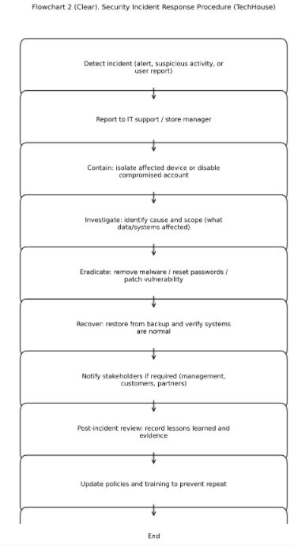

Conclusion
Throughout this report, the role of IT infrastructure, the use of data and information, and the importance of IT policies at Tech House have been analyzed in detail. The findings show that an integrated IT infrastructure plays a key role in managing daily operations, improving decisionmaking quality, and meeting the needs of stakeholders.
The analysis confirms that when centralized software systems, suitable hardware, and reliable network infrastructure work together, sales operations, inventory management, and customer service processes are significantly improved. This conclusion is supported by the real-time operation of POS, ERP, and e-commerce systems, centralized data storage, and management decisions based on accurate information. This approach increases organizational efficiency while simplifying work processes for employees and management.
The analysis of data and information usage shows that effective management of internal and external information flows strengthens trust between stakeholders. Internal information supports coordinated operations within the organization, while external information enables effective communication with customers and business partners. At the same time, improper or uncontrolled use of information can create operational, legal, and reputational risks.
The evaluation of information security and IT policies highlights the real presence of both internal and external threats. The technical and organizational measures implemented to reduce these risks, such as access control, data backup, encryption, and employee training, significantly improve data protection. However, these measures require a balanced approach, as overly strict controls may negatively affect work efficiency.
IT policies developed based on legal, moral, and ethical requirements serve as an important foundation for regulating organizational activities. The selection and justification of these policies were aligned with the organization’s size, business sector, and stakeholder needs. As a result, the policies act not only as protective tools but also as management mechanisms that support stable and responsible operations.
Based on the collected evidence and research findings, it can be concluded that future studies should focus on the expansion of IT systems, the introduction of new digital services, and the changing nature of cybersecurity threats. Research in these areas will help further strengthen TechHouse’s long-term growth and competitiveness.

References
Odoo. (2016). Odoo Security. [online] Available at: https://www.odoo.com/security?
utm_source=chatgpt.com [Accessed 17 Jan. 2026].
Odoo (n.d.). The #1 Open Source CRM Software | Odoo. [online] Odoo S.A. Available at:
https://www.odoo.com/app/crm.
Odoo. (2020). point-of-sale-hardware | Odoo. [online] Available at: https://www.odoo.com/page/point-of-sale-hardware [Accessed 17 Jan. 2026].
Odoo. (n.d.). IoT. [online] Available at: https://www.odoo.com/app/iot.
Odoo.com. (2024). Odoo Documentation — Odoo 17.0 documentation. [online] Available at: https://www.odoo.com/documentation.
Odoo. (2020). point-of-sale-hardware | Odoo. [online] Available at: https://www.odoo.com/page/point-of-sale-hardware [Accessed 17 Jan. 2026].
Odoo.com. (2026). External API — Odoo 17.0 documentation. [online] Available at: https://www.odoo.com/documentation/17.0/developer/reference/external_api.html [Accessed 23 Jan. 2026].
www.odoo.com. (n.d.). Install — Odoo 17.0 documentation. [online] Available at:
https://www.odoo.com/documentation/17.0/administration/install.html.
The Odoo Cloud Platform. (2026). The Odoo Cloud Platform | Official Odoo Hosting. [online] Available at: https://www.odoo.sh [Accessed 23 Jan. 2026].
Odoo S.A. (n.d.). All Apps - Open Source Business Apps: Odoo. [online] Available at: https://www.odoo.com/page/all-apps.
Odoo S.A. (n.d.). Free Website Builder and CMS - Open Source | Odoo. [online] Available at: https://www.odoo.com/app/website.

.

